

Comsats University Islamabad, Attock Campus
Information Security
Lab Assignment 01
Submitted to
Ms. Ambreen Gul
By
Student Name | Registration No
Muhammad Yousaf Qazi | FA23-BSE-030

Graded Task 1:
You have implemented DES there is built in implemented DES in python in crypto cipher module use it for encryption/decryption and provide output sample example?
from Crypto.Cipher import DES
from Crypto.Util.Padding import pad, unpad
from Crypto.Random import get_random_bytes
import binascii
def to_hex(b: bytes) -> str:
return binascii.hexlify(b).decode()
def des_encrypt(data: bytes, key: bytes) -> bytes:
cipher = DES.new(key, DES.MODE_ECB) # Using ECB for simplicity (not recommended for real systems)
padded = pad(data, DES.block_size)
return cipher.encrypt(padded)

def des_decrypt(enc: bytes, key: bytes) -> bytes:
cipher = DES.new(key, DES.MODE_ECB)
decrypted = cipher.decrypt(enc)
return unpad(decrypted, DES.block_size)
fixed_key = b'8bytekey'
plaintext = b"Secret123"
enc = des_encrypt(plaintext, fixed_key)
dec = des_decrypt(enc, fixed_key)
print("=== Example 1: Fixed key (reproducible) ===")
print("Key (ascii):", fixed_key)
print("Key (hex):", to_hex(fixed_key))
print("Plaintext:", plaintext)
print("Ciphertext (hex):", to_hex(enc))
print("Decrypted:", dec)
print()
random_key = get_random_bytes(8)
plaintext2 = b"Hello DES!"
enc2 = des_encrypt(plaintext2, random_key)
dec2 = des_decrypt(enc2, random_key)
print("=== Example 2: Random key ===")
print("Random Key (hex):", to_hex(random_key))
print("Plaintext:", plaintext2)
print("Ciphertext (hex):", to_hex(enc2))
print("Decrypted:", dec2)
print("\nNOTE: DES uses 8-byte keys and block size 8. ECB mode is simple but not secure for many messages.")

Output
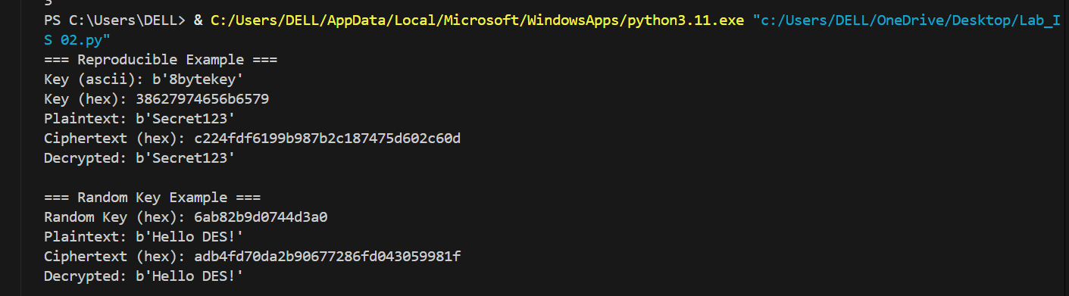

GRADED TASK 2:
Visualization of MITM Attack Flow: Attacker intercepts plaintext (P) and ciphertext (C) 1. Guess K1 P --[Encrypt with K1]--> Intermediate Value 1 (I1) 2. Guess K2 C --[Decrypt with K2]--> Intermediate Value 2 (I2) 3. If I1 == I2, then K1 and K2 are likely correct. Found the DES key: K = K1 + K2?
from Crypto.Cipher import DES
from Crypto.Random import get_random_bytes
import binascii, time, random, sys, traceback

def to_hex(b: bytes) -> str:
return binascii.hexlify(b).decode()
space_bits = 16
show_first_n_candidates = 20
write_filename = "mitm_output.txt"
def make_key_from_val(v: int) -> bytes:
return v.to_bytes(2, 'big') + b'\x00' * 6
def run_mitm_demo(use_fixed_true_keys=False):
out_lines = []
try:
space = 1 << space_bits
plaintext = b'ATTACK!!'
out_lines.append("=== MITM double-DES demo ===")
out_lines.append(f"Keyspace bits (demo): {space_bits} -> {space} keys each")
out_lines.append(f"Plaintext (ascii): {plaintext}")
out_lines.append("")
if use_fixed_true_keys:
true_k1_val = 57251
true_k2_val = 18382
out_lines.append("Using FIXED true keys (reproducible).")
else:
true_k1_val = random.randrange(space)
true_k2_val = random.randrange(space)
out_lines.append("Using RANDOM true keys.")
K1_true = make_key_from_val(true_k1_val)
K2_true = make_key_from_val(true_k2_val)
out_lines.append(f"True K1 value: {true_k1_val} -> K1 hex: {to_hex(K1_true)}")
out_lines.append(f"True K2 value: {true_k2_val} -> K2 hex: {to_hex(K2_true)}")
cipher_k1 = DES.new(K1_true, DES.MODE_ECB)
intermediate = cipher_k1.encrypt(plaintext)
cipher_k2 = DES.new(K2_true, DES.MODE_ECB)
ciphertext = cipher_k2.encrypt(intermediate)
out_lines.append(f"Ciphertext (hex): {to_hex(ciphertext)}")
out_lines.append("")
start = time.time()
out_lines.append("Phase 1: building table E_k1(P) ...")
table = {}
for k1_val in range(space):
k1 = make_key_from_val(k1_val)
I1 = DES.new(k1, DES.MODE_ECB).encrypt(plaintext)
table.setdefault(I1, []).append(k1_val)
phase1_time = time.time()
out_lines.append(f"Phase 1 done. Entries: {len(table)} (built {space} encryptions).")
out_lines.append(f"Time for Phase 1: {phase1_time - start:.4f} seconds")
out_lines.append("")
out_lines.append("Phase 2: checking D_k2(C) and looking up matches ...")
found = []
for k2_val in range(space):
k2 = make_key_from_val(k2_val)
I2 = DES.new(k2, DES.MODE_ECB).decrypt(ciphertext)
if I2 in table:
for k1_candidate in table[I2]:
found.append((k1_candidate, k2_val))
end = time.time()
out_lines.append(f"Phase 2 done. Tried {space} decryptions.")
out_lines.append(f"Time for Phase 2: {end - phase1_time:.4f} seconds")
out_lines.append(f"Total time: {end - start:.4f} seconds")
out_lines.append("")
out_lines.append(f"Number of candidate key pairs found: {len(found)}")
out_lines.append("Showing up to first {} candidate pairs:".format(show_first_n_candidates))
for i, (k1_val, k2_val) in enumerate(found[:show_first_n_candidates]):
out_lines.append(f" [{i+1}] k1_val={k1_val} (K1={to_hex(make_key_from_val(k1_val))}), "
f"k2_val={k2_val} (K2={to_hex(make_key_from_val(k2_val))})")
out_lines.append("")
if (true_k1_val, true_k2_val) in found:
out_lines.append("SUCCESS: The true key pair is among the candidates!")
else:
out_lines.append("NOTICE: True key pair NOT found among candidates (possible but uncommon).")
if found:
k1_val, k2_val = found[0]
K1_guess = make_key_from_val(k1_val)
K2_guess = make_key_from_val(k2_val)
intermediate_guess = DES.new(K1_guess, DES.MODE_ECB).encrypt(plaintext)
intermediate_from_k2 = DES.new(K2_guess, DES.MODE_ECB).decrypt(ciphertext)
out_lines.append("")
out_lines.append("Sanity check (first candidate):")
out_lines.append(f" intermediate from guessed K1 (hex): {to_hex(intermediate_guess)}")
out_lines.append(f" intermediate from decrypting C with guessed K2 (hex): {to_hex(intermediate_from_k2)}")
out_lines.append(" (these should match if candidate is valid)")
else:
out_lines.append("No candidates to sanity-check.")
out_lines.append("")
out_lines.append("Demo finished. Note: this uses a tiny keyspace for teaching. Real DES keys are much larger.")
except Exception as e:
out_lines.append("ERROR during demo:")
out_lines.append(str(e))
out_lines.append("Traceback:")
out_lines.extend(traceback.format_exc().splitlines())
for line in out_lines:
print(line, flush=True)
try:
with open(write_filename, "w", encoding="utf-8") as f:
for line in out_lines:
f.write(line + "\n")
print(f"\nFull log written to '{write_filename}' (open it if console output is missing).", flush=True)
except Exception as e:
print("Failed to write output file:", e, flush=True)
if __name__ == "__main__":
run_mitm_demo(use_fixed_true_keys=False)

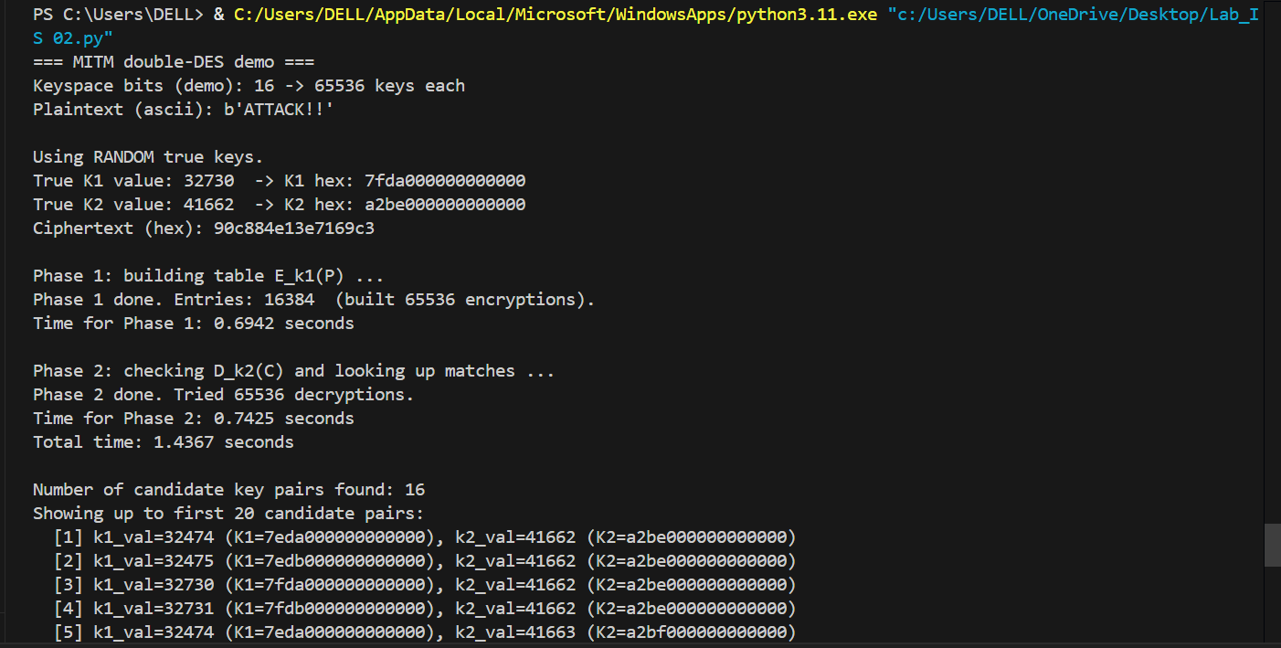
OUTPUT:

